Nama : Dodi Imron, Niko Ahmad Fauzi

NIM : 1127050044, 1127050117

Kelas : IF-B

State And Aktivity Diagram Pemesanan Pizza

1. State Diagram

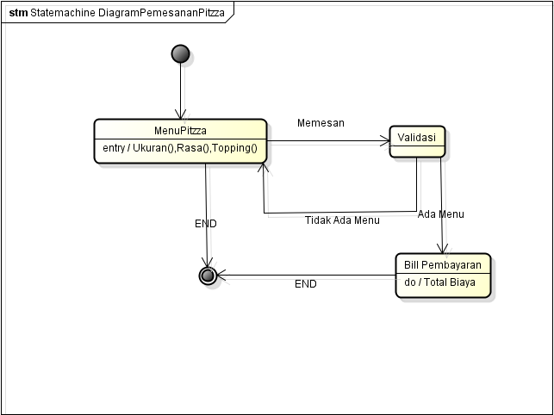

1. Activity Diagram

